8. Changing the device settings.

Device settings change is not supported.

9. Guarantee obligations
The manufacturer guarantees the reliability of the operation of an individual LASERWAR set if the consumer has complied with the conditions of use. Technical support is provided within 12 months of the sale date. The manufacturer undertakes to replace or repair an individual set of equipment free of charge, if the customer has complied with the rules for the device transportation, storage, operation and delivery of defective equipment to Smolensk City.

10. Contact information
Official website:
www.laserwar.com
: Date of purchase: _________________________
E-mail:
info@laserwar.com
help@laserwar.com

Skype:
info@laserwar.com
help@laserwar.com

________________________
signature

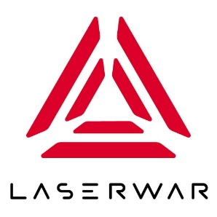
LIMITED LIABILITY COMPANY
LASERWAR

SPECIFICATION
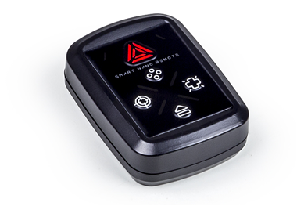

Game set
Nano remote control

1. Description
Nano remote control has five buttons that help to use laser tag equipment during the game.

2. Scope of application
The device is designed for laser tag weapons remote control and is used in organizing sporting events, tactical exercises, corporate and recreational activities.
3. The set includes:
- Nano remote control - 1 pc.
- Specification - 1 pc.

4. Basic technical Data
Length, mm | 70
Width, mm | 50
Thickness, mm | 20
Voltage | 3
Weight, gr | 40

5. Device
The device has a plastic frame of black color.
Inside the frame there is a battery, control junctions, mounting hardware. The frame has infrared emitters, LED, and control buttons.

6. Maintenance
All parts of the set must be treated with care if you want the equipment to function properly. Avoid dirt contamination and damage to IR emitters. There shouldn't be any moisture inside the frame. Change the batteries when needed. Don't hit the device.

7. User's manual
Basic device options “Choose the team color”, “Start/Stop the game”, “Kill the player”, “Friendly fire on/off”, “Shot power 49/99”, “Clear statistics”, “New game”, “Delayed start”, “Healing”, “Anomaly (double health)”.

The 4 buttons that form a rhombus are responsible for choosing the command. The button with red LASERWAR logo serves to fulfill the chosen command. One may select any of the commands by pressing one of the 4 buttons several times. The indicator color will prompt what function you’ve chosen. To apply the chosen parameter press the button with a red triangle.

The scheme below illustrates the list of the commands (the order of the colors downward: red, blue, green, yellow).

Smart Nano Remote will switch off automatically after 1 minute of inactivity. The Remote also may be switched off by pressing and holding for two seconds any of its buttons.
