
LIMITED
LIABILITY COMPANY
LASERTAG

SPECIFICATION

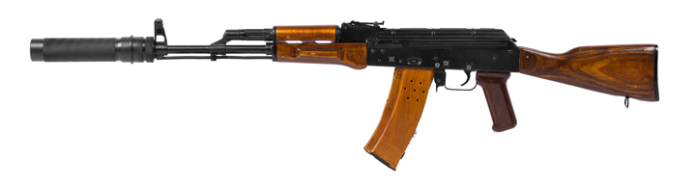

Game set
AKM LEGEND
STEEL edition

Smolensk

In addition, during use of headbands, the device can experience mechanical damage to the caps that protect the sensors. In such cases, the caps must be replaced. It is necessary to recharge headbands immediately, no longer than 80 minutes after the game.
It is necessary to store the equipment in a well-ventilated space at temperature from + 18°C to + 30°C and relative humidity of 45-65%.
Store equipment only in charged state (ideally under nominal voltage conditions).

- Guarantee commitment
The manufacturer guarantees the reliability of the operation of an individual LASERWAR set if the consumer has complied with the conditions of use. The manufacturer undertakes to replace or repair an individual set of equipment free of charge, if the customer has complied with the rules for the device transportation, storage, operation and delivery of defective equipment to Smolensk City.
The warranty is 14 days for batteries, speakers, and IR modules.
PLEASE NOTE! In the case of improper operation of the accumulator (charging by an unrelated type of a charger), the warranty doesn't cover the battery!

You can see on our website a complete technical maintenance manual for laser tag equipment: www.laserwar.ru.

- Operating rules
1. Weather conditions. We strongly recommend that the equipment shouldn't be used in the rain and at temperatures below -20 °C.
Avoid getting moisture inside the device. If this happened, turn off the device, dry the equipment at room temperature for at least two hours.
Having used the device at low temperatures don't try to charge it immediately after the game. Wait for electronics to warm up.
2. Batteries. The device from the "STEEL" series has lithium batteries. To recharge the device use only universal Li+ chargers.
Connect the charger to the device, and only then to the network.
You can control the recharge process with the help of a special indicator. If the battery is low, the LED is red; When the recharge process is complete, the color will be changed to green.
Please note! The game set must be recharged immediately after you have played with it under constant supervision at temperature no less than 0°С and no longer than for 2 hours.
3. Headband When using headbands pay attention to hygienic cuffs. They will protect electronic parts from moisture. If the bandage gets wet, it can result in the electronics failure. That's why the bandage should be dried.

6
7
- Description and work
  - Device
The АKМ LEGEND STEEL edition game set consists of two parts: a sound-and-light rifle and a headband with hit sensors.
The connection between the weapon and rifle is effected with the help of Bluetooth technology.
The АKМ LEGEND STEEL edition game set is shown on the Diagram No. 1.

Diagram No. 1

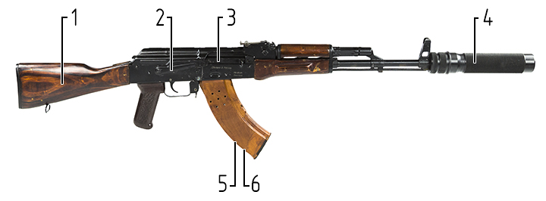

1 – buttstock (not collapsible).
2 – safety catch.
3 – bolt for reloading.
4 – optical system.
5 – anti-vandal power lock
6 – power socket.

Information on the repairs performed during the maintenance period (completed by the Service centre performing the warranty repair works).

Date: __________________  Completed work: _____________________________________________________________________  Service centre stamp | Date: __________________  Completed work: _____________________________________________________________________  Service centre stamp
Date: __________________  Completed work: _____________________________________________________________________  Service centre stamp | Date: __________________  Completed work: _____________________________________________________________________  Service centre stamp
Date: __________________  Completed work: _____________________________________________________________________  Service centre stamp | Date: __________________  Completed work: _____________________________________________________________________  Service centre stamp

3
10
  - Changing the performance characteristics
The performance characteristics are changed with the help of LASERTAG-configurator.
The LASERTAG-configurator program is shown in Figure 1.

Figure 1
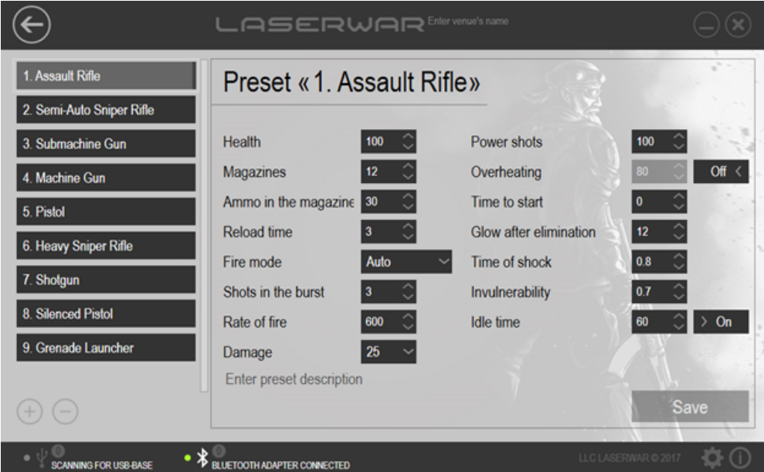

Connect a Bluetooth base to your PC (use a Bluetooth adapter if your pc doesn't support Bluetooth); turn the weapon on. You needn't turn on the headband. The main configurator window will display the active BT connection and the number of connected devices. Select the preset you want to use, click "Write" to apply. A new window will display all active connected devices, their ID, the type of weapon, firmware version, and serial number. Click the refresh button if no devices are found.

Warranty Terms:

1. The guarantee is effective upon presentation of the present certificate, which indicates the purchase date of the equipment confirmed by the service centre.

2. These guarantee obligations apply to products acquired only from the official LASERTAG representative or the official dealer.

3. The present guarantee is invalid if the product deficiencies have occurred in the following cases:
- failure to comply with Operating instructions;
- mechanical damage;
- penetration of extraneous items, liquids, etc.;
- animal activities;
- unauthorized access to the parts of the game set by non-authorized persons;
- use of the product for purposes for which it hasn't been made;
- Acts of elements (natural disaster, fire, accidents, etc.);
- the game set malfunction in case of faulty power network and/or poor care of the product.

4. If the warranty certificate is lost, no duplicate is issued.

4
9
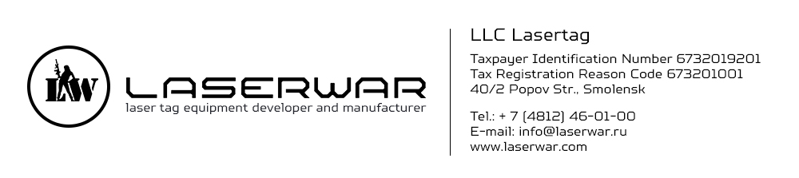

Dear Customer!

Our company welcomes and thanks you for the decision to buy our products, and is confident that the purchased device will bring you a long-term pleasure. The warranty certificate establishes the guarantee of the product in the amount provided for by the Law on consumer protection of the Russian Federation.
This warranty certificate is valid for 18 months from the purchase date of the product, provided the guarantee terms are observed.

Choose the required game set by ticking the appropriate box. Press the "Write" button. Having confirmed the changes, restart the game set.

  - Pre-starting procedure
To activate the AKM LEGEND STEEL edition game set turn on the weapon and headband. Having connected the headband and weapon will enter the standby mode. The diodes will start blinking frequently. Then run the "New game" command using a remote control.
The device is ready to use.

8
5

Purchase Date: _______________
- Contact information
Official website:
www.laserwar.ru

E-mail:
info@laserwar.ru
support@laserwar.ru

Skype:
info-laserwar.ru
support laserwar.ru


_____________________
Stamp signature

Equipment version: Serial Number:

v.8 Sport 

v.9 Smart RGB + feedback

 v.9 Smart RGB + feedback + OLED

- The intent of the device
The АКМ LEGEND STEEL edition game set is a sound-and-light rifle designed to play laser tag.

- Technical Specifications
Weight | 3.4 kg
Length | 107 cm
Battery type | Li +;  7.4 V; 2200 mAh
Battery charger Type | automatic, Li +
Battery life | up to 30 h
Range of fire | 185 m
Software programs | LASERTAG-configurator

- Contents of delivery
№  Ser. No. | Name | Unit of Measure | Quantity
1. | Sound-and-light rifle | pc. | 1
2. | Specification | pc. | 1

11
2

